Soul Health Education

New Term starts Saturday March 2018
- Learn the secret art of Living and enjoying your best life NOW.
- Expand your conscious awareness to re-discover your infinite, limitless potential.
- Learn how to increase your capacity to manage and ease physical and emotional pain.
- Access life-codes and tools guaranteed to boost your confidence.
- Develop skills that will help you to face and manage difficult situations, build healthy relationships, and feel better about yourself.
- Discover how soul-health impacts the ecosystems.

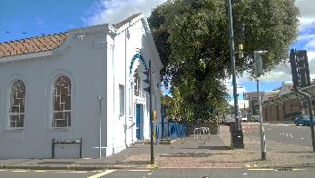
VENUE: The Old Fishponds Library. Fishponds Road. Bristol. BS16 3UH Oposite Morrisons Supermarket. Parking. Bus Stops Nearby.

ROLLING ADMISSIONS POLICY
1st Saturday of the Month
Class Dates: 1st Term Sat Mar 3rd April 7th, May 5th, Jun 2nd
Summer Break Jul -Aug
2nd Term Sep 8th, Oct 6th, Nov 3rd, Dec 1st
Winter Break Dec – Jan
3rd Term 2019 Feb 9th, Mar 9th, Apr 6th, May 4th,
Graduation June 1st, 2019
Ongoing admission after start date!!

SOUL CLINIC - SOUL FITNESS
Obliterate mood swings, Manage Chronic Fatigue, and Knockout Depression
“ At Life Universcity we get to wake up!
And live the Magnificent Life we’ve been
Dreaming”
Quote – Chancellor

Registration/Enquiries

- Telephone: 07508390298 Admin
- Email: life.Universecity@gmail.com
- Or use the The Contact Us tab:
onwww.themagnificentway.com/lifeuniversecity Here you will find a lot more about Life Universecity, review the Courses, see photos and learn how to enroll.
- BOOK & MAKE PAYMENTS: https://www.eventbrite.co.uk/myevent/43474607722/reports/attendee/

